l  Using Bloomberg in Excel | ISD Library



CONTENTS

INTRODUCTION
COVERAGE
AVAILABILTY
HELP
SIMPLE DATA DOWNLOADING FROM BLOOMBERG TO EXCEL
DRAG AND DROP TICKERS FROM BLOOMBERG, THEN DOWNLOAD DATA WITHIN EXCEL
CREATE SEARCHES AND CAPTURE DATA WITHIN EXCEL [for historic end-of-day time series]
EXCEL FORMULAE TO CAPTURE ‘LIVE’ BLOOMBERG DATA

INTRODUCTION

COVERAGE
Bloomberg covers 4.6 million fixed income securities, 420,000 global equities, as well as commodities, currencies and funds. The electronic library also comprises text data on almost every publicly traded company, news and biographies of more than one million people.
Bloomberg API within Excel offers all the functionality of Excel plus Bloomberg data. Bloomberg menu items and icons plus easy-to-use formulae/statements allow easy capture of static and live-updating single data items and data time series.

AVAILABILITY
Bloomberg is only available to current students, faculty and staff. It is installed on all PCs in the Finance zone on the 2nd Floor of the Library and also one PC in the student lounge. The Excel add-in is available on all PCs running the full Bloomberg service.

HELP
- When in Excel, go to the Bloomberg menu and select Help Contents, or if you need to live chat with a Bloomberg helpdesk advisor click on the green HELP button.
- Ask Library staff for assistance, either at the main desk or by emailing library@london.edu

SIMPLE DATA DOWNLOADING FROM BLOOMBERG TO EXCEL

Exporting static tabular data into Excel
The Export to Excel option can usually be found by clicking on Output. If static data is in a graph, right click on the graph and you should see Copy/Export Options, you will need to copy and paste the graph and data in two separate processes.

Exporting tickers from Bloomberg to Excel using drag-and-drop functions

Use on screens such as EQS (equity screening) results screens, MEMB (lists of index members), MA merger and acquisitions league tables and search results, and from NW worksheets.
N.B. when dropping a list of tickers into the worksheet, leave a cell free at the top of the column of tickers.

- A [two boxes and a green arrow] icon appears at the top right of the screen, enabling drag and drop of all tickers on the current screen into an Excel worksheet.
- Now go to ‘Running searches using the Field Search box’ instructions on page 3 of this guide to see how to input field labels and populate the worksheet with data.

Full Excel download

- Shown as a sub-item under Output in a results table’s red heading border.
- Data should save straight into into Excel.
- NB if a worksheet containing ‘live’ Bloomberg data is opened on a Bloomberg-API terminal, the data will immediately begin to update (overwriting the earlier data) unless the Live/Static toggle button is set to Static.

DRAG AND DROP TICKERS FROM BLOOMBERG, THEN DOWNLOAD DATA WITHIN EXCEL

- Drag and drop a ticker or list of tickers from Bloomberg into an Excel worksheet using the ‘two boxes and a green arrow’ functions (see instructions for this on the previous page of this guide). N.B. leave a cell free at the top of the column of tickers.

- Place the cursor in the top cell of the column next to the column of tickers.

- Click on Bloomberg > Find Fields

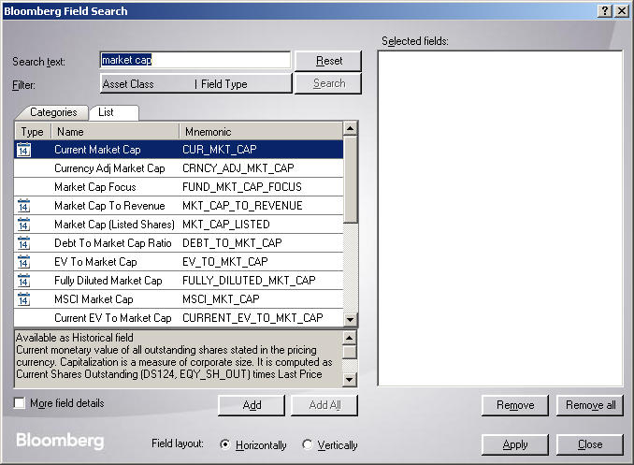

- Browse or search for the Field labels. Note the definitions in the grey box near the bottom of the Field Search box.

- Click OK and the field labels will insert themselves at the top of the columns of the worksheet.

- Place the cursor in the empty ‘home cell’ above the tickers and to the left of the data field labels heading the columns.

- Click the [Populate Table] icon (a spreadsheet with a + symbol on it) on the Bloomberg toolbar. The columns will be populated.

- NB, this data is live. To protect the data from automatic updates uncheck the Real-Time Updates box on the Bloomberg toolbar.

CREATE SEARCHES AND CAPTURE DATA WITHIN EXCEL
[for historic time series]

First, locate the cursor on the worksheet so data downloaded by this search will not overwrite pre-existing data. Begin the search by clicking on the [Import Data] icon (a blue grid topped by an orange triangle). Then choose ‘Real-Time/Historical’>’Historical End of Day’.

Step 1. Find a security or list of securities

For all methods, the desired securities must be listed in the ‘Selected securities’ box before clicking [Next].

a) In the ‘Enter security’ section type a security ticker/CUSIP/SEDOL or start typing the company name into the ‘Security identifier’ box. By default the Market sector is set to Equity, but you can change this setting as required. When you have found the correct company/commodity/bond etc.. either double click on it or click on it and then on ‘Add’. It should then appear in the ‘Selected securities’ box.

Or

b) In the ‘Select securities’ section select the desired ‘From’ choice, and then select from the next drop-down in order to move the content into the ‘Available securities’ box. Then click [Add all]. NB this method enables importing of securities from indices or from pre-existing Bloomberg NW Monitors or equity searches (EQS) or from an Excel worksheet…

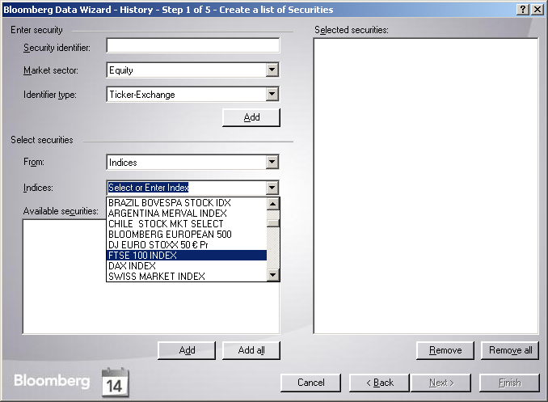

Step 1. Create a security or list of securities (cont.)

c) To import a range of security names from an existing spreadsheet.
First, change the ‘Select securities’ ‘From’ drop-down to ‘Spreadsheet’.
Then;

Either
- In ‘Range’ enter the range in standard Excel format e.g. $B$1:$D$1.
- Click [Import] and the securities will be listed in the ‘Selected securities’ box.
- Click [Next].

Or
- Click the [Spreadsheet] icon (red, white and blue icon to right of the ‘Range’ field). The small ‘Range’ input field will appear.
- Highlight the range of cells in the worksheet to be loaded into the wizard. These cells’ range description will automatically populate the ‘Range’ input field.
- Click the [Return] icon (letterbox-like icon to right of the small ‘Range’ input field).
- Click [Import] and the securities will be listed in the ‘Selected securities’ box.
- Click [Next].

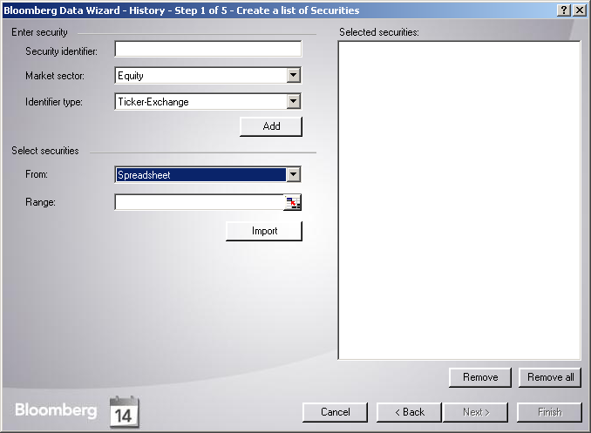

Step 2. Create a list of data fields

For all methods, the desired fields must be listed in the ‘Selected securities’ box before clicking [Next].

a) Browse by ‘Categories’, or;

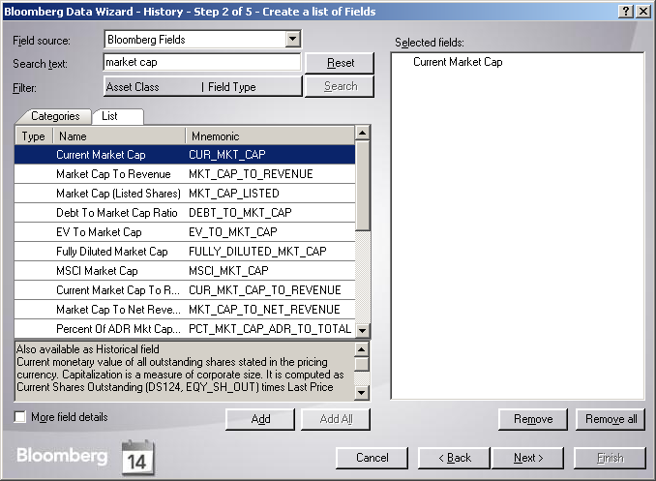

b) Search using the ‘Search text’ box and the ‘Filter’ options, or;

Step 3. Set the date ranges

N.B. European date order, dd/mm/yyyy.
Then click [Next]

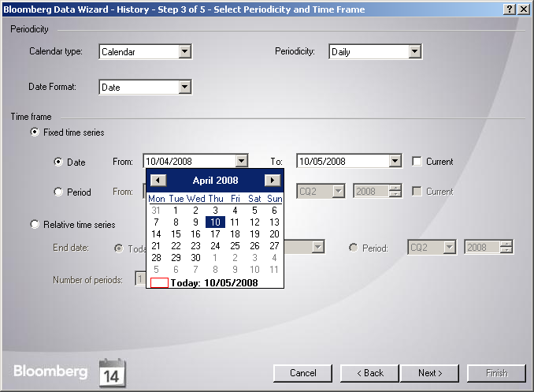

Step 4. Set the history parameters, including currency

Then click [Next]

Further layout options are available by clicking on ‘Next’ or you can click on Finish at this stage.

Click [Finish] and the data will download straight into the workbook.

N.B. some data fields update ‘live’ e.g. LAST_PRICE does, but PX_LAST does not. This live updating will happen whenever the worksheet is open and connected to Bloomberg API.
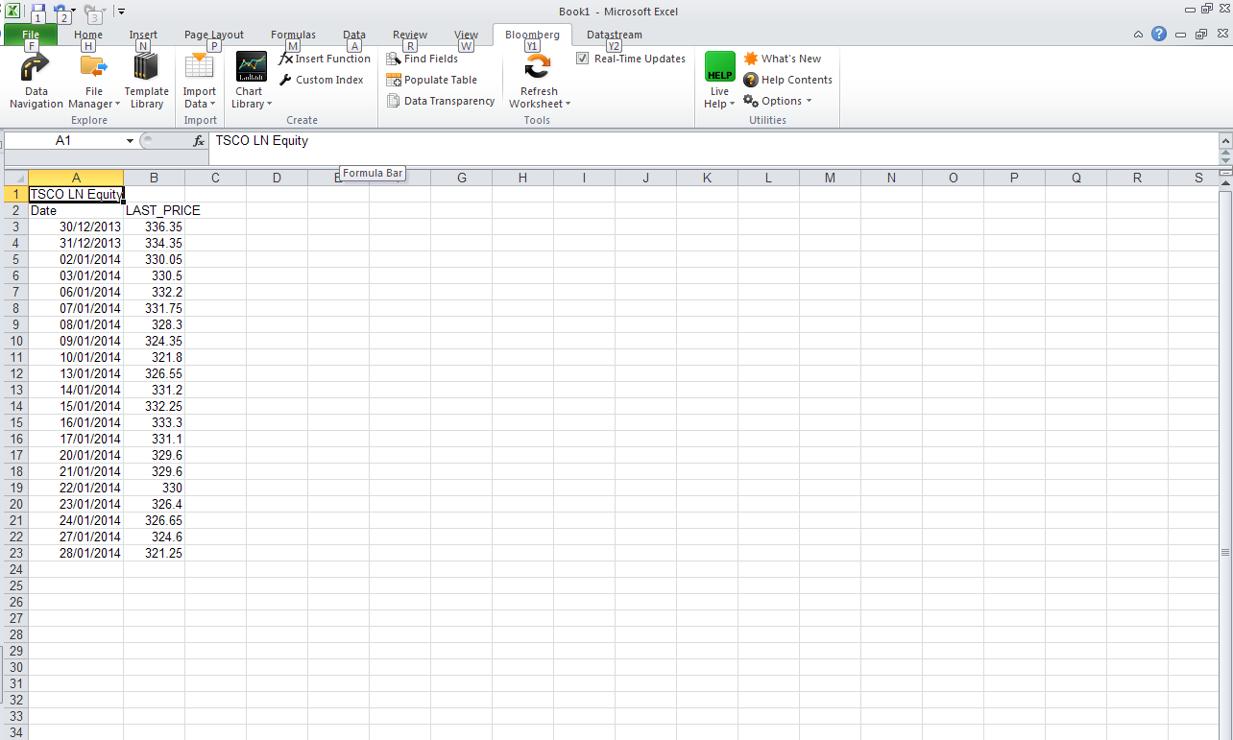

EXCEL FORMULAE TO CAPTURE LIVE BLOOMBERG DATA

Enter these formulae into a cell using the fx field above the worksheet within Excel.
NB some Bloomberg keyboards transpose “ and @
NB in the images below, column and row data appears at the end of the formulae; this is added automatically by Excel.

A single data point, for example a single last daily closing price
- Formula =bdp(“ticker and security type”,”data field”)
- Example =bdp(“tsco ln equity”,”px_last”)

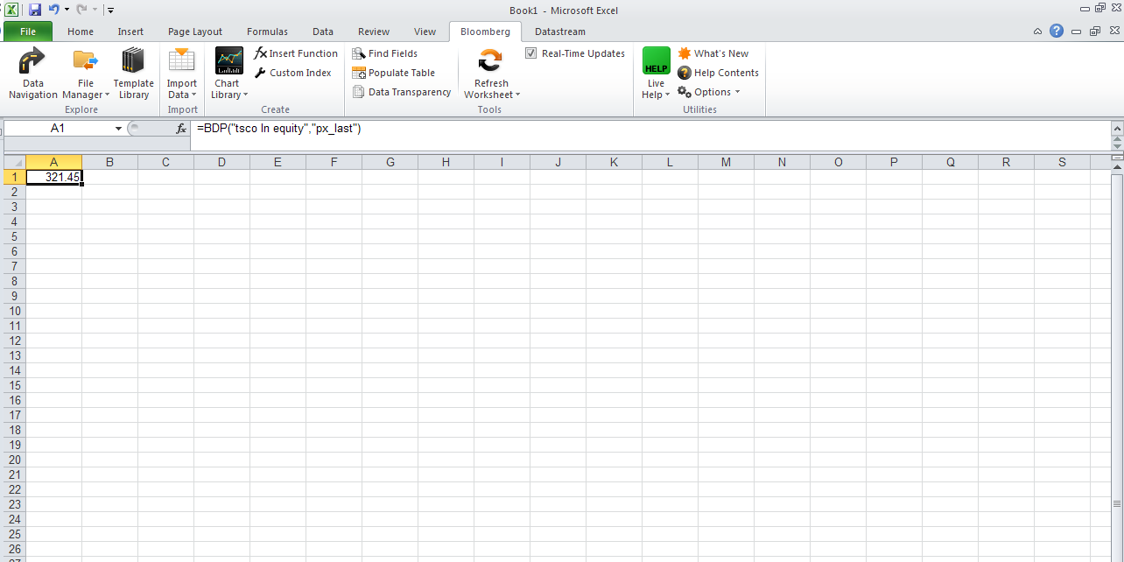

A single data field which contains multiple data points for example a company’s description, several sentences long.
- Formula =bds(“ticker and security type”,”data field”)
- Example =bds(“tsco ln equity”,”cie_des_bulk”)
- Ignore the column and row parameters in the formula line in the image below; Excel adds these automatically

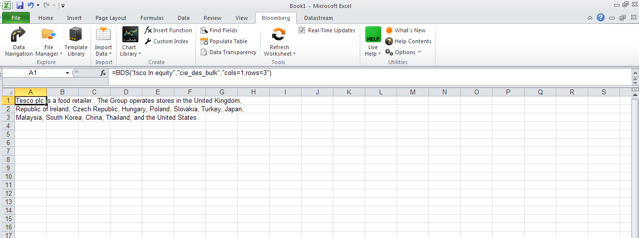

USING FORMULAE cont.

A historic data time series, for example a company’s daily closing price for three months. N.B. enter dates in European date order i.e. dd/mm/yyyy
- Formula =bdh(“ticker and security type”,”data field”,”start date”,”end date”)
- Example =bdh(“tsco ln equity”,”px_last”,”01/11/2013”,”27/01/2014”)

